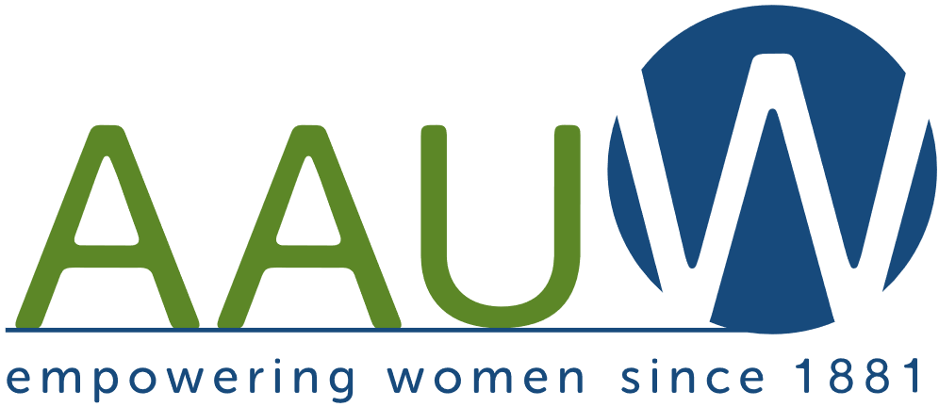 | Advancing Education and Equity for Women  and Girls through Advocacy, Education, Philanthropy, and Research

Founded in Boston in 1881, the mission of the American Association of University Women (AAUW) is to advance equity for women and girls through advocacy, education, and research. AAUW has a national membership of over 170,000 members and supporters, 1,000 local branches, and 800 college and university partners. Find information on AAUW programs at https://www.aauw.org.

FELLOWSHIPS & GRANTS
American & International Fellowships – Career Development Grants
Community Action Grants - Research Publication Grants in Engineering, Medicine and Science
AAUW has granted a total of over $115 million dollars in Fellowships and Grants to women scholars.

College/University Membership (C/U)
Public and Private Colleges and Universities & Community Colleges Staff, Faculty, and Students Benefit from AAUW Membership
C/U membership opens doors to grants and fellowships, leadership training, professional development, educational resources, and advocacy tools. C/U membership is $175.

LEADERSHIP & SKILL DEVELOPMENT AAUW offers leadership and skill development programs for members, college women, and girls.
- National Conference of College Women Student Leaders (NCCWSL) – Brings together student leaders from across the U.S. to engage in leadership training.
- Work Smart – Start Smart – Workshops attendees learn successful salary negotiation strategies.
- STEM Programs for girls including: Tech Savy - a science, technology, engineering, and math (STEM) conference for 6th–9th grade girls; Tech Trek - Problem solving and meeting women role models in STEM, helps middle school girls learn about careers in STEM. STEMEd for Girls is a virtual series of workshops that show how STEM skills expand career opportunities.

ADVOCACY
AAUW advocacy focuses on legislation that impacts girls and women including: the Equal Pay Act; the Title IX amendment in 1972; the Family and Medical Leave Act in 1993; the Lilly Ledbetter Fair Pay Act in 2009 …
RESEARCH
Research on contemporary issues include: The Simple Truth About the Gender Pay Gap; The STEM Gap: Women and Girls in Science, Technology, Engineering, Math (STEM); Factory FLAW: The Attrition and Retention of Women in Manufacturing; Barriers & Bias: The Status of Women in Leadership…

Find information on AAUW programs at https://www.aauw.org.
Advancing Education and Equity for Women and Girls through Advocacy, Education, Philanthropy, and Research

AAUW–Massachusetts (AAUW-MA)
AAUW-MA works with local branches to advance equity and education for girls and women through advocacy, community action projects, providing financial support for fellowships and research, hosting book discussions that address contemporary issues, organizing STEM programs for girls and collaborating with organizations committed to diversity, equity, and inclusion to address DEI issues.
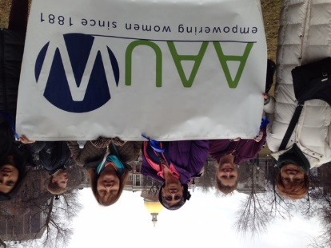 | 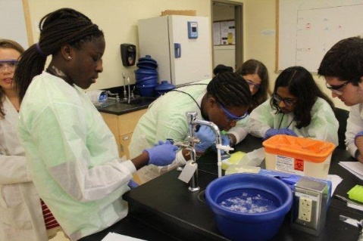 | 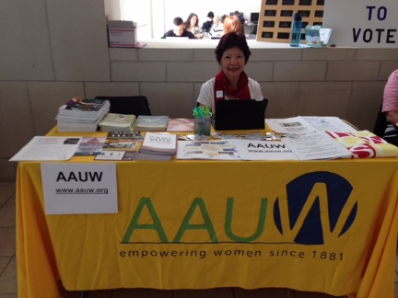
Advocacy | STEM Programs for Girls | Community Action Projects

AAUW-MA
AAUW- MA welcomes new members who hold an associate or equivalent or baccalaureate degree or higher from a qualified educational institution. Undergraduates may join as student affiliates.

MA Membership Information Contact: Hollie Bagley at holliebagley@gmail.com.

AAUW-MA Branches
If you would like more information on a branch in your area, contact information is below.

- Boston Sandra Walker at sandra.walker@lesley.edu
- Canton Jane Valin at janevalin@aol.com
- Cape Cod Elsa Murphy at elsa.e.murphy@gmail.com
- Melrose-Wakefield Mary Pat Swarte at tmpdeswarte@aol.com
- North Shore Area Mary Ann Walsh at mawalsh28@verizon.net
- South Shore Area Gail Saccone at gvsaccone@comcast.net
Anne Foley at annefoley15@gmail.com
- Taunton Area Susan St. Germain at rssaint@comcast.net
- Worcester Elizabeth (Betty) Orsi at orsi.elizabeth@gmail.com

Updated Nov. 20 2021 chb

