WHY STEM
Developing 21st Century Skills Needed by All Ages

 |  | 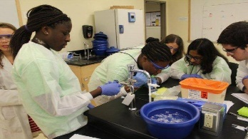
Connecting  Generations | Understanding  Contemporary Issues | Expanding Career  Opportunities

Living in the 21st Century, necessitates literacy in STEM (science, technology, engineering and math)
for people of all ages. In the workplace, STEM expertise expands career opportunities for individuals
and sustains economic growth for businesses. Increasingly those involved in enacting legislation,
developing public policy, and voting for political candidates and referendum questions need to be knowledgeable about STEM related issues such as the importance of access to technology, digital
literacy, cyber security, reproductive health, infectious disease management, inflation, climate change, stem-cell research, space exploration, fossil fuels, clean energy, and a host of other issues.

JOIN US
Learn How You Can Support STEM Programs for Girls – Meet AAUW STEM Advocates

STEM Conference for Girls
Saturday, October 22, 2022
Hosted by the Weymouth Public Schools & AAUW-MA South Shore Area Branch, girls in grades 4-8 will listen to a keynote speaker and participate in three interactive workshops for attendees. Attendees will have the opportunity to meet women in STEM and learn about a variety of STEM careers including coding, engineering, healthcare, robotics, science, math, and many more. If you would like to support the STEM Conference for Girls, contact Lynn Howard at lynnphoward97@gmail.com

Educating for the future
Virtual Program
Wednesday, September 21, 2022 – 4-6:30PM
MA STEM Week (Oct. 17th-21st), encompass PK-16 learning opportunities to increase student interest & raise awareness about STEM education. Join Lynn Howard, AAUW-MA STEM Chair, as she participates in a session on MA STEM Week and focuses on the role of AAUW in ensuring girls develop the STEM skills they need to expand career opportunities at the STEM Conference for Girls – Saturday, October 22, 2022 at Weymouth High School.
Register at: http://events.constantcontact.com/register/event?llr=los9hgeab&oeidk=a07ejc5azi24448d094

